After school club for years 3 and 4 have taken place which involved design, build and evaluation using Lego bricks. Children worked individually, in pairs and groups.

Years 5 and 6 have worked with mechanisms and moving parts to design, make and evaluate a moon rover.

Children have the opportunity to do take home tasks which are based on our Learning Journeys and are linked to D.T.

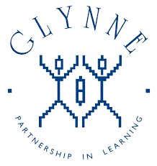

Years 1 and 2 have designed, built and evaluated hedgehog hibernation stations and used different sewing techniques to make a giant’s hat.

Many different examples of pupils creative D.T. skills displayed in each year group around the school.

New display in the dining hall to promote nutrition and healthy eating in school.

Glynne Primary School

What does

Design and Technology look like?

Learning to cook is a crucial life skill which enables pupils to prepare and cook using a variety of techniques.

D.T. demonstrates aspects of design, build and evaluation.

D.T. resources are reviewed regularly.

D.T. subject leader completes annual action plan which is reviewed and shared with governors.

Each class cooks once per term to include a variety of sweet and savoury dishes, linked to their learning.

Important aspects of nutrition are also taught to classes each term.

Book trawls, monitoring and observations carried out by subject leader and feedback given.

Parents are given the opportunity to assist with projects in D.T such as Victorian bridge building in Years 3 and 4 and Tudor houses in Years 5 and 6.

**Subject Ambassadors**

Children in Year 3 to Year 6 have been selected as Subject Ambassadors to champion their subject and share their ideas about D.T throughout school.

Irresistible Learning provides cross- curricular learning.

Tea parties and questionnaires for representatives from each year group have taken place to ascertain knowledge of D.T.

Years 3 and 4 have designed, made and evaluated ship’s lanterns.